Horizon 65mm Multi-Tool Compatible with AFC-746AKT Machine
Waste Stripper Installation Guide
Please read through these instructions completely before attempting installation.

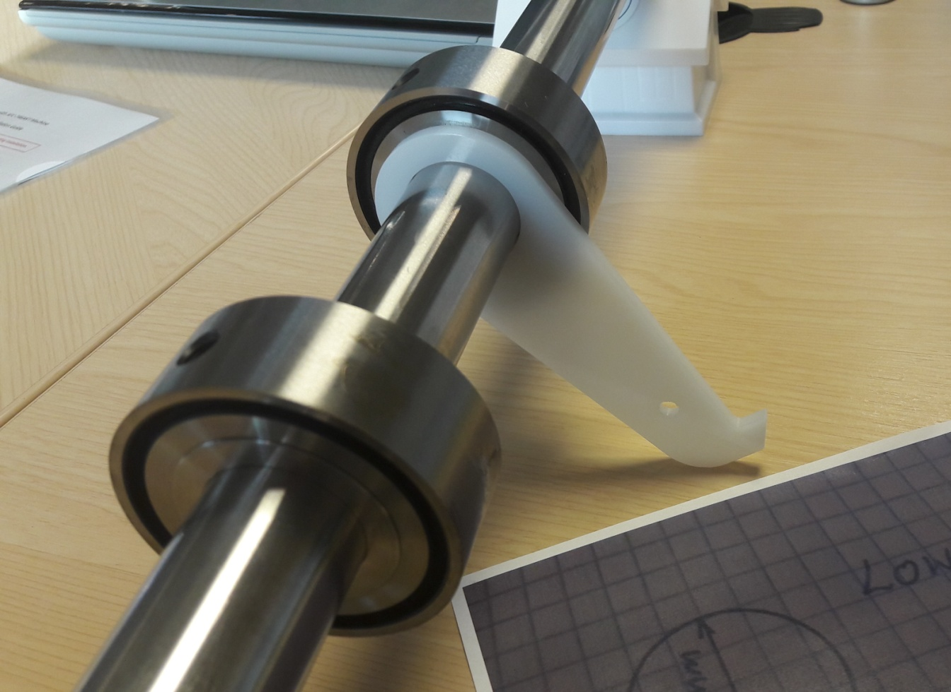
Direction of Paper Travel
Waste Stripper Removal Guide – Fixing Hole
Waste Stripper Removal Guide - Hooked End
View of Lower Exit Shaft – For Gulley Cutting or Centre-Trimming Applications Only
When applying the bottom exit shaft ensure the Waste Stripper Removal Guide is placed in between the 2x Adapter Collar and Cutting Boss assemblies as shown in the above picture. And slide the Cutting Boss units together and position on shaft as required.
Ensure the Waste Stripper Removal Guide is installed the way up as shown in the above picture.
The hooked end of the Waste Stripper Removal Guide should rest freely on top of the fixing bar situated within the folding machine.
If the Waste Stripper Removal Guide falls short of the fixing bar then insert a piece of string or wire through the hole engineered within the Waste Stripper Removal Guide and attach around the fixing bar to secure.


